# **Overhead View:**

DoggyLocksTM Is a very simple system comprised of two ultrasonic sensors, one servo motor, a connection base and a MicroBit to control it.

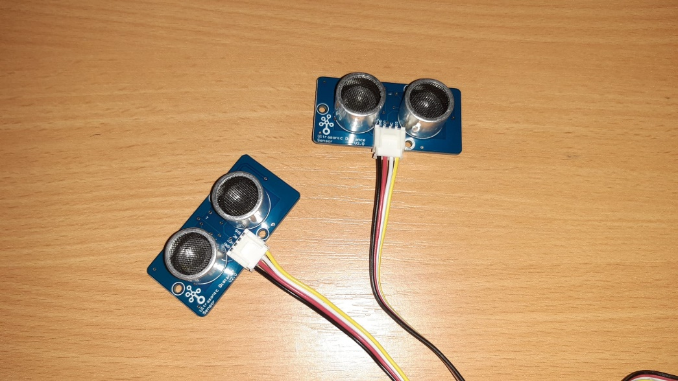

# **Sensors:**

These simple ultrasonic sensors will connect just inside and just outside your door so that your dog can leave and enter again.

**Motor:**

While this is only the prototype motor this is very similar to the motor that will be used in your own DoggyLocksTM setup. The motor will be attached to the doors hinges and be used to open it.